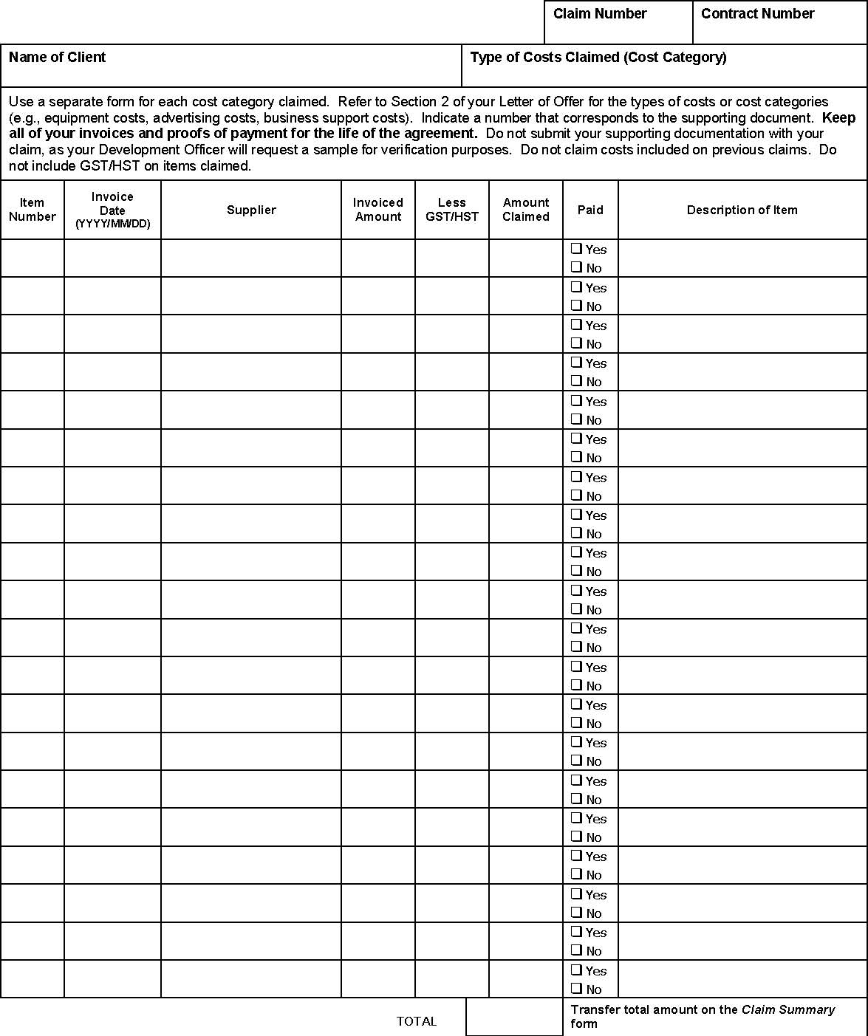
Use a separate form for each cost category claimed. Refer to Section 2 of the arrangement for the types of costs or cost categories (e.g. equipment costs, advertising costs, business support costs, etc.). Indicate a number that corresponds to the supporting document. Keep all you Invoices and proofs of payment for the life of the arrangement. Do not claim costs included on previous claims. Do not include GST/HST on items claimed.

DETAILED ELIGIBLE COSTS

